UNIT -2
1.Discuss the architecture of a multilayer perception and its working.
An MLP is a feedforward artificial neural network ( ANN) that consists of multiple layers of neurons.
It is one of the most fundamental architectures in deep learning and machine learning, used for tasks such as classification, regression, and pattern recognition.
2. Architecture of MLP
The MLP consists of three main types of layers:
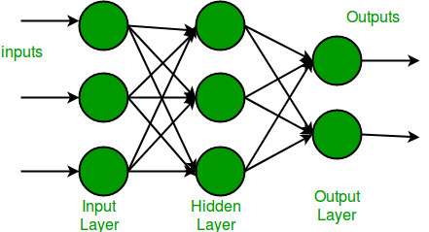
a. Input Layer
- Takes input features from the dataset.
- Number of neurons = number of input features.
- No Action is done here; it simply passes the data to the next layer.
b. Hidden Layer(s)
- One or more layers between input and output.
- Each neuron in a hidden layer performs weighted summation and applies an activation function.
- 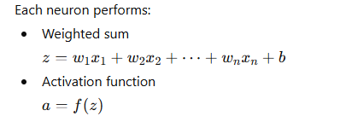
- These layers allow the network to learn complex patterns.
- These layers learn the internal representation and abstract features.
c. Output Layer
- Produces the final output.
- 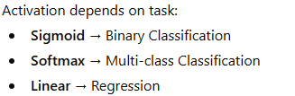
3. Working of MLP (Forward and Backward Pass)
Step 1: Forward Propagation
- Input data is passed through the network.
- Each layer computes the output and passes it to the next.
- At the end, the output layer produces predictions.
Step 2: Loss Calculation
- The difference between predicted and actual output is computed using a loss function:
  - MSE for regression
  - Cross-entropy for classification
Step 3: Backpropagation
- Calculates the gradient of the loss with respect to each weight using the chain rule.
- This error is propagated backward through the network.
- Error is propagated backward through the layers.
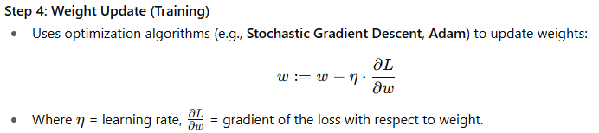
Applications
- Image and speech recognition
- Fraud detection
- Medical diagnosis
- Stock market prediction
- Natural language processing (NLP)

2.Explain the process of backpropagation in training deep networks.
Backpropagation is an algorithm used to update the weights and biases in a neural network by minimizing the error between predicted and actual outputs. It’s based on gradient descent and the chain rule of calculus.

Phases of Backpropagation
Backpropagation is done in two main phases after a forward pass:
- Forward Propagation (calculate output)
- Backward Propagation (calculate gradients)
- Weight Update (using optimization)
1. Forward Pass
- Input data is passed through the network layer by layer.
- Each neuron computes a weighted sum and applies an activation function.
- The final output is generated.
Step 2: Loss Calculation
- The difference between predicted and actual output is computed using a loss function:
  - MSE for regression
  - Cross-entropy for classification
Step 3: Backpropagation
- Calculates the gradient of the loss with respect to each weight using the chain rule.
- Error is propagated backward through the layers.

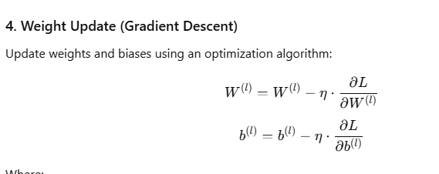

3.Describe the concept of autoencoders and their application.
An autoencoder is a type of unsupervised neural network that tries to reconstruct its input. It consists of two main parts:
1. Encoder
- Compresses the input into a lower-dimensional representation (called the latent space or code).
- Learns the most important features of the input.
2.Latent Space (Code)
- The compressed form of the input data (also called the bottleneck).
- Contains the most important features.

3. Decoder
- Reconstructs the original input from the compressed representation.
- Tries to minimize the difference between the input and the output.
Applications
1. Dimensionality Reduction
Change from higher dimensions to lower
2. Denoising
- Trained to reconstruct clean data from noisy input.
- Common in image and audio processing.
4. Image Compression
- Encodes images into compact representations.
- Can be used for efficient storage and transmission.
5. Feature Extraction
- Latent space captures meaningful features.
- These can be used for downstream tasks like classification.
3. Generative Models
- can generate new data samples.
- Widely used in creative AI and synthetic data generation.
4.What is greedy layer-wise training? Why is it used in deep learning?
Greedy layer-wise training is a method of training deep neural networks one layer at a time, rather than training the entire network all at once. It’s called “greedy” because each layer is trained independently to optimize its own performance before moving on to the next.
Greedy Layer-Wise Training is a training strategy used in deep neural networks where the network is trained *one layer at a time*, rather than training all layers simultaneously. Each layer is trained independently to learn useful feature representations, and once trained, its weights are frozen before moving on to the next layer.
*How it Works:*
1. *Start with the first layer:*
* Train the first hidden layer directly on the raw input data to extract low-level features.
* Example: In images, it may learn edges or textures.

2. *Freeze the first layer:*

* After training, its parameters are fixed so they won’t be changed further.

3. *Train the next layer:*

* The output of the first layer becomes the input for the second layer.
* The second layer learns higher-level features from the already transformed data.

4. *Repeat the process:*

* Continue training subsequent layers in the same way.

5. *Fine-tuning:*

* After all layers are pre-trained, the whole network can be fine-tuned with backpropagation to improve overall performance.

Greedy layer-wise training was especially useful in the early days of deep learning for several reasons:
✅ 1. Overcomes Vanishing Gradient Problem
- In deep networks, gradients can become very small during backpropagation, making learning difficult.
- Layer-wise training avoids this by training shallow networks first.
✅ 2. Improves Initialization
- Each layer starts with weights that are already tuned to extract useful features.
- This leads to better convergence during final training.
✅ 3. Efficient Feature Learning
- Each layer learns increasingly abstract representations.
- Useful in unsupervised learning tasks and pretraining.
✅ 4. Reduces Computational Load
- Training one layer at a time is less demanding than training a deep network end-to-end from scratch.

- Explain in detail about Empirical Risk Minimization,
- What is regularization and explain the types with all the mathematics behind

